Lab Assignment – 2

Implement Ridge Regularization and the Lasso Regularization in Python

Dataset: <https://github.com/JWarmenhoven/ISLRpython/blob/master/Notebooks/Data/Hitters.csv>

Code:-

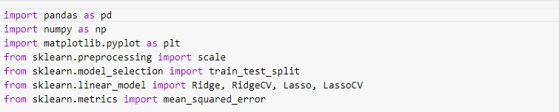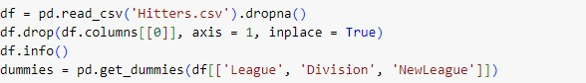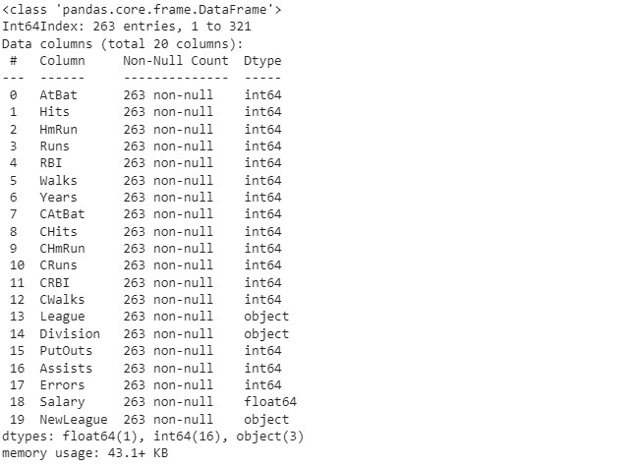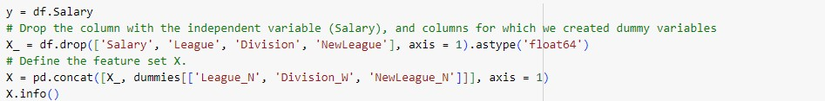

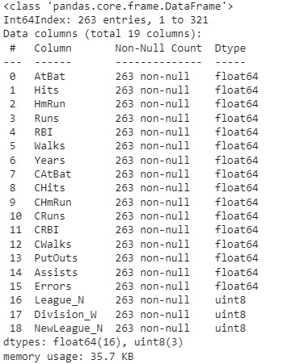

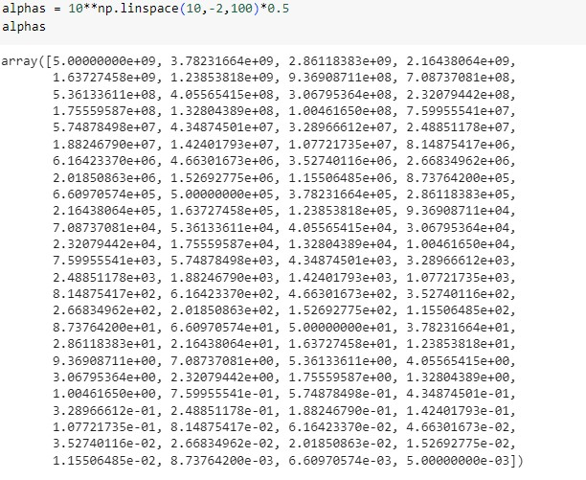

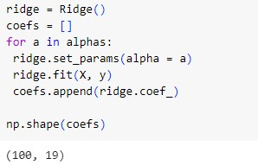

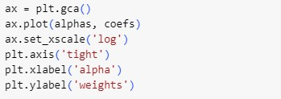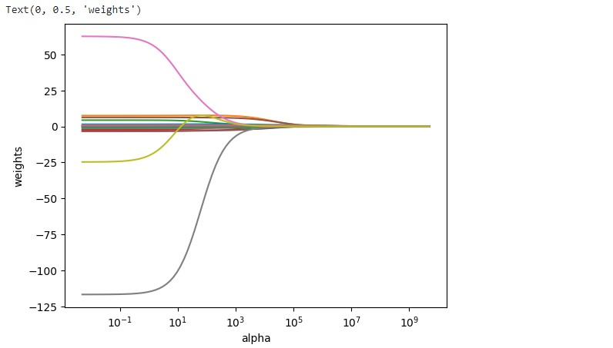

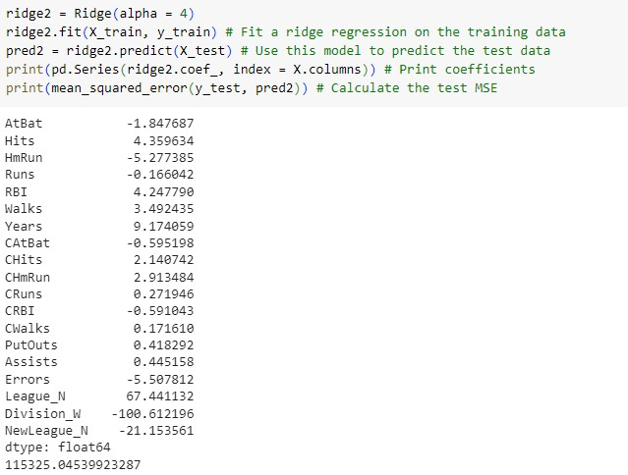

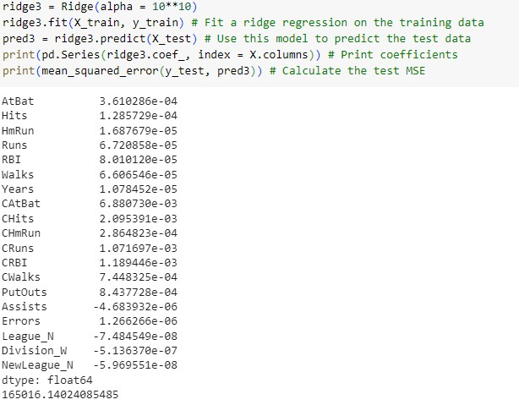

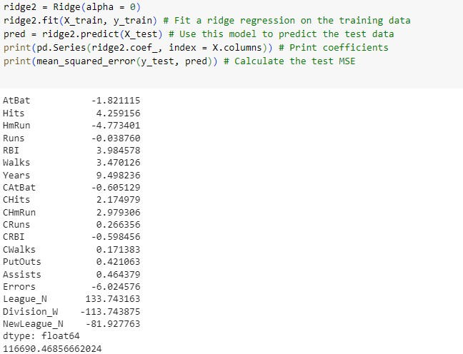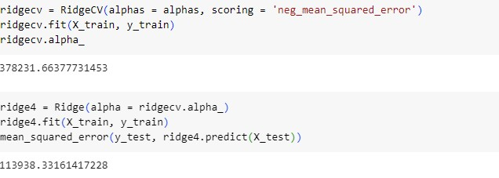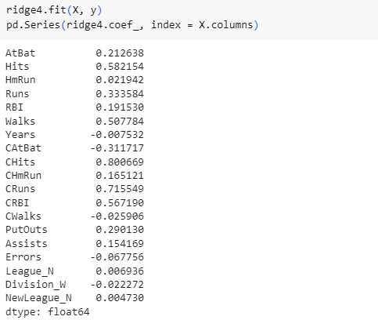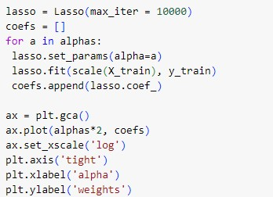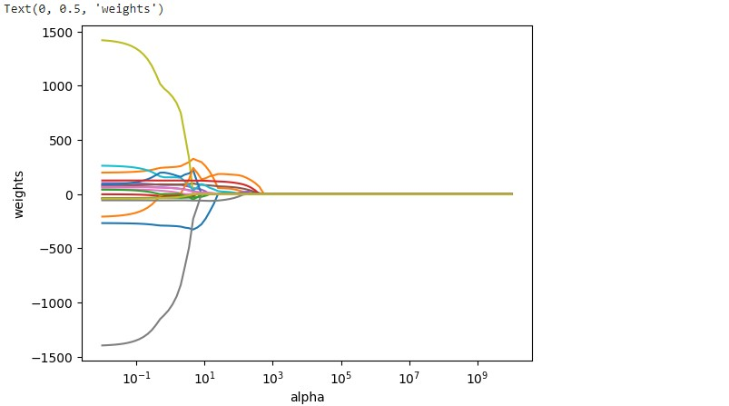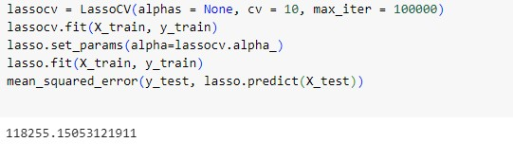

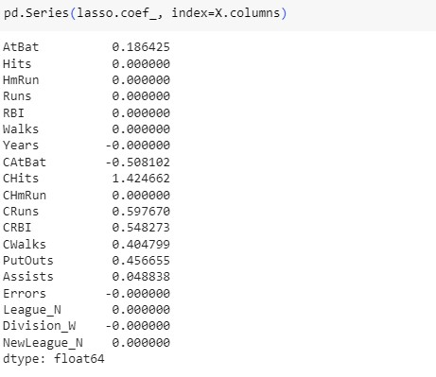

**Interpretation:**

* Ridge and lasso regression are regularization techniques used to prevent overfitting in linear regression models.
* The choice of alpha determines the strength of regularization, with higher alpha leading to more regularization.
  + As we can see from the output of the code, when the value of alpha is small the output values are significantly small but when the alpha is increased the output values decreases with higher rate.
* The code assesses model performance using mean squared error on the test set for both ridge and lasso regression.
* Cross-validation is employed to find optimal alpha values for ridge and lasso, enhancing model generalization.